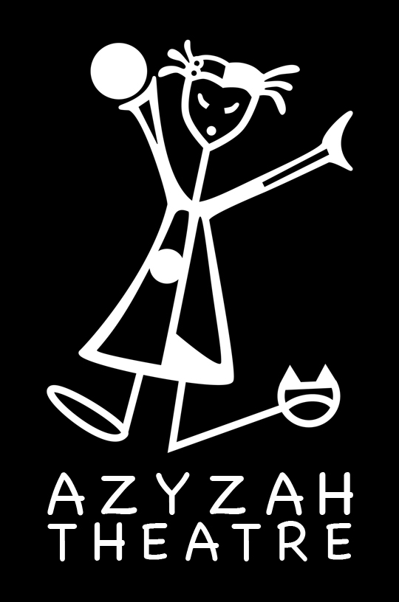

Azyzah Theatre
English Educational Theatre

Whoop Concert * Student/Teacher Material
Exercises for students (before the performance)

This Student / Teacher Pack contains lesson plans related to the interactive Magic Concert show.

All lessons are a supplement to the show for preschool & basic schools year 1-3 and may be adapted to each level as teachers see fit.

Azyzah Theatre may be contacted for guidance related to all lessons.

Contact:
Vanessa Gendron ( Director, Creator)
tel. (+420) 608 454 655
email. Vanessa@azyzah.com
www.azyzah.com

FOCUS
Students will learn a multiple of magic tricks, practice answering in English, introductions, colors.

Supporting materials are :

-Worksheets
-Interactive game where we explore each song
-Communicative English

TOPIC 1 Comprehension

The students will become magicians during the show by following instructions, introducing themselves and re-enforcement of basic English.

Main focus is on colors.
Find the color for each magical object in the show.

Flower, wand, suitcase, scarves, balloons, animals, snake, flute, book, weights.

Blue

Red

Green

Yellow

Black

Orange

TOPIC 2 – Song Lyrics

Learning a language is particularly encouraging when you can sing to it. Students love to sing. Singing with movement helps to discover the meaning of each word and the message of the entire song.

1) Rock you

We will, we will rock you.
*continue with rhythm and different sounds

2) If your happy

If your happy and you know it clap your hands.
Stomp your feet.
Shout hurray.
Do all three.

Wow Magic Show WORKSHEET 2

If your happy

Directions: Fill in the spaces by using the words from the word bank.

Know clap feet

shout

If your____________and you know it!

__________ know your hands.

If your happy and you __________ it!

Stomp your __________.

If your happy and you know it!

__________hurray!

Wow Magic Show WORKSHEET 3

Creating their own Magic Show in English.
Find different scarves or create instruments with beans and plates or empty plastic bottles. Students can enter as a musical train and prepare a magic trick by asking students what the magic word it. They can try and make objects disappear or create their own special magic.

