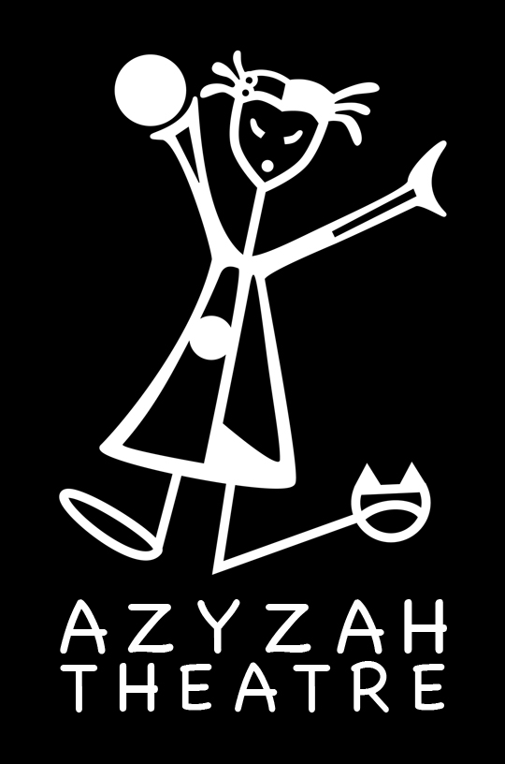
Azyzah Theatre

The Decoding Mission * Student/Teacher Pack
Exercises (before / after the performance)

This Student / Teacher Pack contains lesson plans related to the interactive performance of the Decoding Mission.
All lessons are a supplement to the show for students in year 4,5,6,7 and may be adapted to each level as teachers see fit.

Azyzah Theatre may be contacted for guidance related to all lessons.

Contact:
Vanessa Gendron ( Director, Creator)
tel. (+420) 608 454 655
email. Vanessa@azyzah.com
www.azyzah.com

FOCUS
Our focus is to give students the chance to understand the basics of the Decoding Mission.

Supporting materials are:

-Comprehension
-Descriptions
-Questions
-Decoding
-Creative writing

TOPIC 1 – Comprehension

Tell the children the basic story outline of the Decoding Mission in order for them to understand the premise.
Mr. Suits and Kiki find themselves in a dystopian world where an evil source as taken over the planet by creating a virus called the Black AIR Virus. There are only a few people left who could save the planet from being completely contaminated by the virus.. Kiki and Mr. Suits are part of the resistance. They will need the help of the tree friends and the book of prophecies they realize that they might be the two saviours.

During their adventure they will train with a Master, meet a Sorceress, a creature of smell, the black army soldiers, the white source and the black source.

Will they save the planet in time.. will they be able to decode the codes?!

TOPIC 2–Character description

Describe the characters in the play. Kiki, Mr. Suits, Anonymous, Master Yin Yang, Ninja ja ja, The Sorceress, the Creature of Smell, the soldiers, the white/black source.

Example: Kiki is tall. She likes to read the book of prophecies. She finds a bag of chips at the beginning of the play and becomes very good at meditation..... AND SO ON....

TOPIC 3 - Questions

1.What does Kiki find?

2.Who are the two saviours?

3.What is the name of the hacker?

4.What is the name of the virus?

5.Who trains Kiki and Mr. Suits in the art of Ninja?

6.How can Mr. Suits and Kiki enter the tree of wisdom?

7.Who needs to help Kiki and Mr. Suits to find out where the black source is?

8.How does the virus kill humans?

9.What is the code?!

10.How do Kiki, Mr. Suits and their tree friends save the planet?

Topic 4 – Decoding

In pairs try to create your own decoding game where people have to figure out a message of some sort.

Topic 5 – Create Writing
Create your own Dystopian short story and act it out.

Topic 6 – Saving the planet (video, debate)
Discuss with students how we can help the planet by recycling and changing the way we consume. You could do a talk show and make a video of kids interviewing scientists about the eco system.

