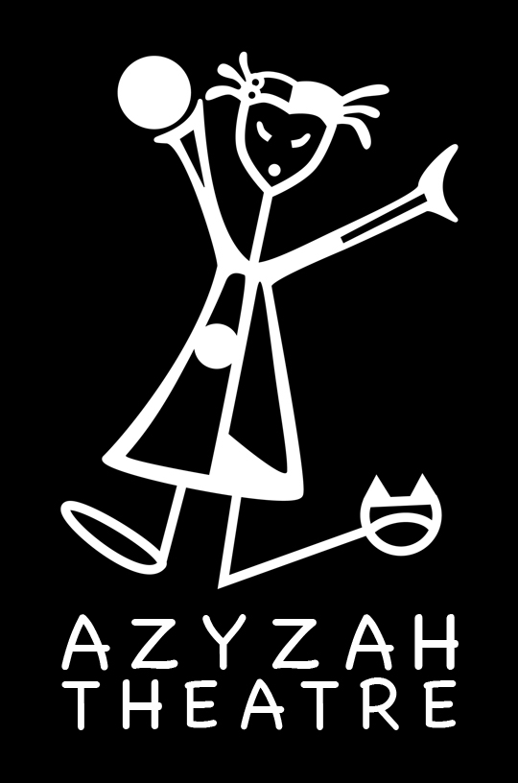

Azyzah Theatre
English Educational Theatre

Green Eggs and Ham * Student/Teacher Material
Exercises for students (before or after the performance)

This Student / Teacher Pack contains lesson plans related to the interactive performance of Green Eggs and Ham.

All lessons are a supplement to the show for preschool & basic school: year 1-3 and may be adapted to each level as teachers see fit.

Azyzah Theatre may be contacted for guidance related to all lessons.
Contact:
Vanessa Gendron ( Director / Creator)
tel. (+420) 608 454 655
email. azyzahgendron@gmail.com
facebook: https://www.facebook.com/Azyzah.Theatre/
www.azyzah.com

FOCUS

The goal will be for the students to write their own short story about a type of food they like based on words that rhyme in the:

Green Eggs and Ham book by: Dr. Seuss.

Supporting materials are:

-Original Dr. Seuss book Green Eggs and Ham
-Worksheets
-How to make a book

TOPIC 1 – Interactive listening / comprehension

Lesson accessories: white board, makers, book, 20 small books, large A3 book, magic marker, flashcards, tack-it pack, writing pencils and colouring pencils or markers for kids, dictionary, clip pad.

Good Morning everyone!
Students repeat: Good morning!

I am …(name of teacher)…and I will read you a very funny story today.
Could everyone get comfortable and find a space where you can all see properly.
It is very important that you listen carefully since I will ask you some questions after the story.

Read the Story: Green Eggs and Ham by Dr. Seuss.
if you have a copy*
If you do not have a copy here is a link https://www.youtube.com/watch?v=KmC1btSZP7U

Introduce the book by asking what it says on the cover (the title and author)

While reading the story ask key questions:

-What colour is his hat, hand, the eggs, house, the mouse, boat, goat, rain, train, tree, car, fox, box

-Character emotions (happy-sad – angry, scared, annoyed)

-What is his name?

-What does Sam want the funny man with the black hat to eat ?

-Where is he sitting?

-What does the man with the Top hat not like.

WORKSHEET 1 Questions

WORKSHEET 2 / Rhymes
(Can be given another day for extra re-enforcement.)

Name: _____________________

Green Eggs and Ham WORKSHEET 1
Answer the questions in a full sentence.

A-The man with the top hat does not like what?

_____________________________________________________________

B-Does he like them at the beginning of the story or at the end?

_____________________________________________________________

C-Where does he not like them? There are 8 answers to this question.

D-What colour are the eggs and the ham?

______________________________________

E-What is the name of the little character who wants the man with the black top hat to eat the green eggs and ham?

___________________________________________________

F-Where do they all fall at the end of the story?

___________________________________________________

Name: _____________________

Green Eggs and Ham WORKSHEET 2
Directions: Draw a line to match the words that rhyme.

house boat

goat train

fox tree

rain there

here box

be dark

car mouse

TOPIC 2 – Writing skills
Let's write our own short story

We will create our own short story like Dr. Seuss' Green Eggs and Ham in our very own small book. We will write about what we like to eat, where and with who!

First, I will need your help to write my story in order for you to see how to make the book and then you will be able to write and make your own.

(Use the white board / large book / insert on each page)

1st What do we need to write on the cover of our book? (Title and author)

Title: Chicken and Rice (draw picture) by: Pavla

2nd Like in the Green Eggs and Ham book - the first page we see is Sam
Introducing himself

I am Pavla (draw a picture of yourself) Pavla I am.

3rd On our 1st / 2nd / 3rd / 4th - 5th THE END page we will write:

Where and with who you would you like to eat your favourite food?

-Have them match the rhyming words by using the flashcards / come up to the board

-Have them do their own books once all rhymes are made and sentences written on the board

PAGE 1 I would eat them in a______. (box) / I would eat them with a ________.(fox)

PAGE 2 I would eat them in the _________.(rain) / I would eat them on________.(train)

PAGE 3 I would eat them in a____.(house) / I would eat them with a ______.(mouse)

PAGE 4 I would eat them with a _____.(goat) / I would eat them on a ________.(boat)

PAGE 5 Say, I love Chicken and Rice! I do!

